

**ASIA PACIFIC UNIVERSITY**

**TECHNOLOGY & INNOVATION**

ENGINEERING PROJECT MANAGEMENT

EE019-3-3-EPM

|  |  |
| --- | --- |
| TITLE | Engineering Project Management (Cafeteria) |
| NAME & STUDENT ID | Darvwesvaar Sivapragasam (TP063497)  Goh Kwok Liang (TP060257)  Makhmudov Ismail (TP061888)  Jason Seah (TP068036)  Shaik Yaseen (TP06290)  Zainab Yasmin (TP068362) |
| INTAKE | APD/APU3F2402ME/EEE/PE/CE |
| LECTURER | Ir. Ts. Dr. Dhakshyani Ratnadurai |
| SUBMISSION DATE | 25th September 2024 |

Table of Contents

List of Figures 3

List of Tables 4

Introduction 5

Site Analysis 6

Scope Statement 7

Floor plan 9

Work Breakdown Structure (WBS) 18

Network Diagram 30

PDM Network Diagram 33

Critical Path: 41

Gantt Chart: 43

Cost Estimates 45

Labor Cost 46

Raw Material Cost 51

Equipment Rental Cost 55

Total Cost Estimation 56

Conclusion 57

References 58

# List of Figures

Figure 1 Location of New Cafeteria 6

Figure 2 Floor Plan 9

Figure 3 Full Cafeteria 3D View 9

Figure 4 Entertainment Area 3D View 10

Figure 5 Cafe 3D View 10

Figure 6 Kiosk Station 3D View 11

Figure 7 Dining Area 3D View 11

Figure 8 Kitchen 1 3D View 11

Figure 9 Kitchen 2 3D View 12

Figure 10 Kitchen 3 3D View 12

Figure 11 Lounge Area 3D View 12

Figure 12 Assignment Corner 3D View 13

Figure 13 Handwash Station 2 3D View 14

Figure 14 Handwash Station 1 3D View 14

Figure 15 Toilet 3D View 1 14

Figure 16 Toilet 3D View 2 15

Figure 17 Prayer Room 3D View 15

Figure 18 Emergency Exit 3D View 16

Figure 19 CCTV's 3D View 17

Figure 20 Fire Extinguisher 3D View 17

Figure 21 WBS Diagram 19

Figure 22 PDM Diagram Section 1 35

Figure 23 PDM Diagram Section 2 36

Figure 24 PDM Diagram Section 3 37

Figure 25 PDM Diagram Section 4 38

Figure 26 PDM Diagram Section 5 39

Figure 27 Gantt Chart 43

# List of Tables

Table 1 Critical Path 42

Table 2 Foundation and Structural Work 46

Table 3 Interior Construction 47

Table 4 Interior Installations 48

Table 5 Pedestrian Bridge Construction 49

Table 6 Exterior Finishing 50

Table 7 Pedestrian Bridge Materials 51

Table 8 Foundation and Structural Work 52

Table 9 Interior Construction & Installation 53

Table 10 Furniture, Fixtures, and Equipment 54

Table 11 Equipment Rental Cost 55

Table 12 Total Cost Estimation 56

# Introduction

Because engineering projects are usually complicated, costly, and high-risk, the field of engineering project management is in great demand among employers and necessitates a solid understanding of skills that are not covered in an engineer's undergraduate education. Effective management of engineering projects is ultimately about influencing people at all levels and ensuring that each work stream is executed to specification, finished on time, is within budget, and fulfills any legal or regulatory requirements.

The current cafeteria faces challenges like overcrowding and long wait times due to limited space, affecting students, staff, and visitors. To resolve these issues, APU’s Property Development Department has initiated a project to build a modern facility that can comfortably accommodate up to 250 people. The project aims to provide a more spacious, comfortable, and efficient dining environment while ensuring sustainability, safety, and compliance with modern standards. This report details the project scope, work breakdown structure, cost estimates, and scheduling, outlining the steps necessary to complete the cafeteria by the end of 2024.

# Site Analysis

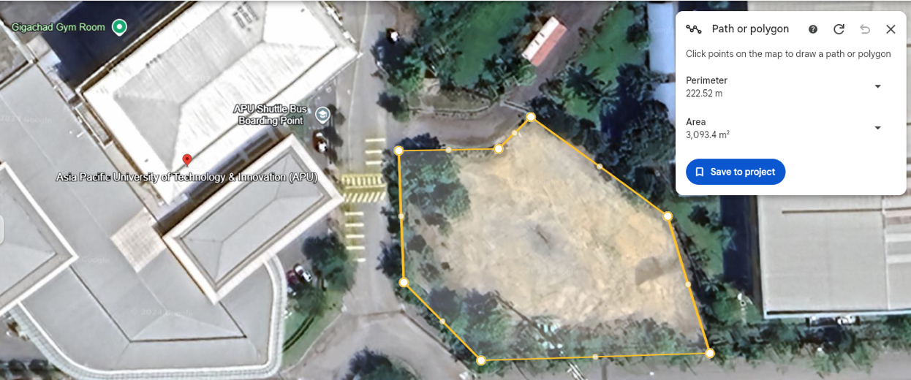

Figure 1 Location of New Cafeteria

The proposed site for the new cafeteria is located opposite the Asia Pacific University (APU) New Campus, adjacent to the APU Shuttle Bus Boarding Point. The selected plot is highlighted in yellow, covering an area of approximately 3,000 square meters. The site is strategically positioned within close proximity to the main campus, ensuring easy access for students, staff, and visitors.

This location is ideal due to its open space, allowing sufficient room for the development of a cafeteria that can accommodate up to 250 people. The area is well-connected to the surrounding pathways, promoting easy foot traffic flow. Additionally, the proximity to existing infrastructure such as the shuttle bus stop ensures convenience for commuting students and staff. The presence of greenery around the site further supports the potential for incorporating sustainable and environmentally friendly design elements.

Overall, the site provides ample space and accessibility, making it a suitable location for the new cafeteria construction.

# Scope Statement

|  |  |  |
| --- | --- | --- |
| Scope Statement | | |
| Project Title | New Cafeteria Opposite APU |
| Project Manager | Darvwesvaar A/L Sivapragasam |
| Project Objectives | **Specific (S)**   * Design new dining area, kitchen, walkway, food counter, toilet, surau at the empty space opposite of APU. * Every part from planning until opening should be prepared in detail.   **Measurable (M)**   * Able to fit 6 food stalls, and 250 people within the area. * Design 70% of the total area used as dining area which is approximately 2165 meters square.   **Achievable (A)**   * All space must be utilized with feasible design * The project should not exceed the budget set at the beginning of the project.   **Relevant (R)**   * Software such as QR menu and table finding software will be implemented and able to be used when the cafeteria opens. * Robot waiters should be ready to serve people in the cafeteria when the project is done.   **Time (T)**   * By 1st Jan 2025, the cafeteria should be fully operational, with food stalls ready to sell food. There should be no ongoing renovation or construction work. * The timeline should follow the network diagram |
| Scope Description | * Dining area with 250 seats, and QR code order system on table. * Kitchen with clean and safety design * Clear and accessible walkways. * Implement robot waiters and table finding software. |
| Project Deliverables | * Architectural blueprints * Technology integration plans * Interior finishing with technologies implemented. * Setup of kiosks, QR order systems, and robot waiters. * Development and deployment of table finding software. * Final inspection for quality check and approval from APU. |
| Project exclusions | Walkway to the new cafeteria, parking lot design, maintenance and support for smart technologies after completion and kitchen equipment. |
| Project constraints | * The project should be done within the given budget * Project must be complete by 31st Dec 2024 * Space given must be managed effectively |
| Project assumption | * All required permits and approvals will be obtained on time. * The project team can access all the necessary resources and labor. |

# Floor plan

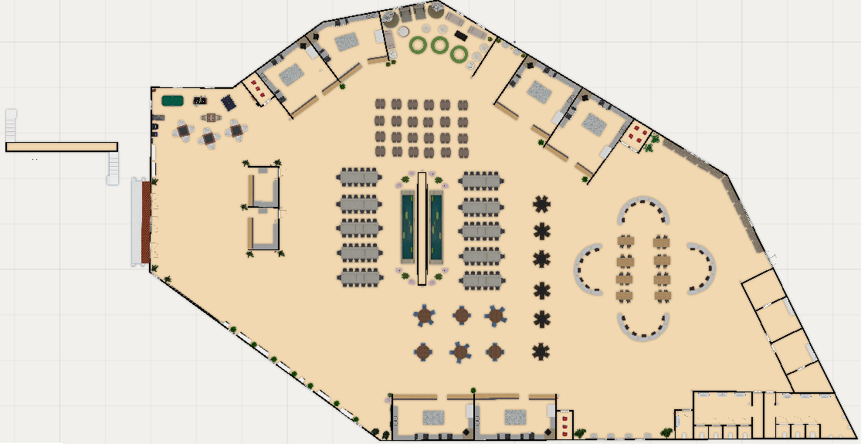

Figure 2 Floor Plan

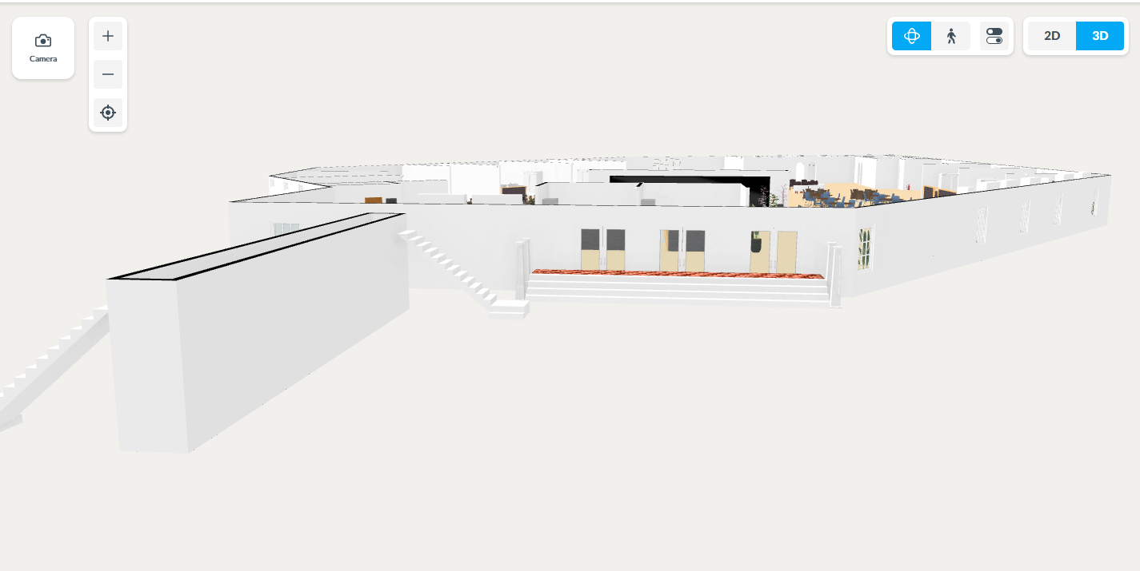

Figure 3 Full Cafeteria 3D View

Entertainment Area & Vending Machines

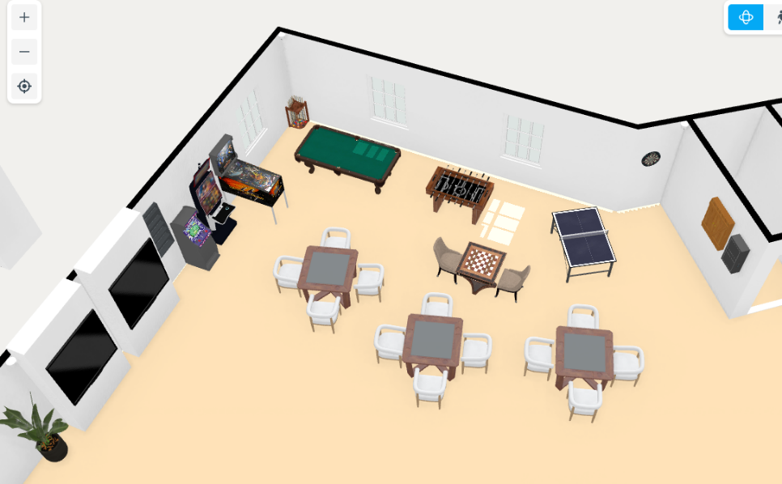

Figure 4 Entertainment Area 3D View

Cafes

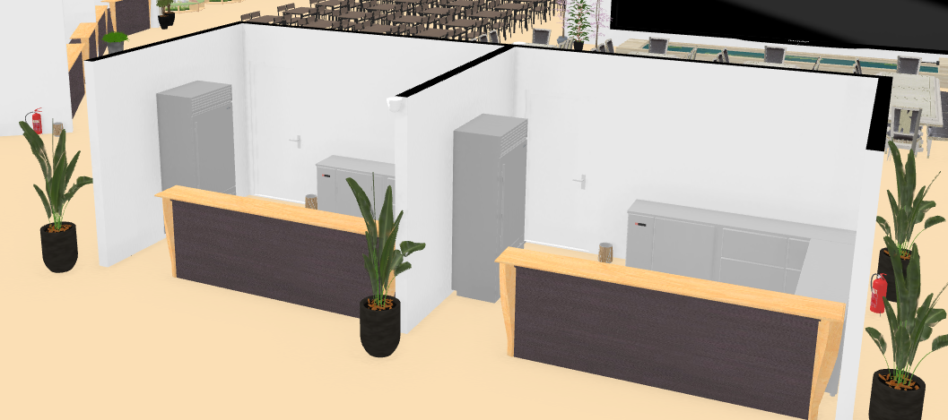

Figure 5 Cafe 3D View

Kiosk Ordering Stations

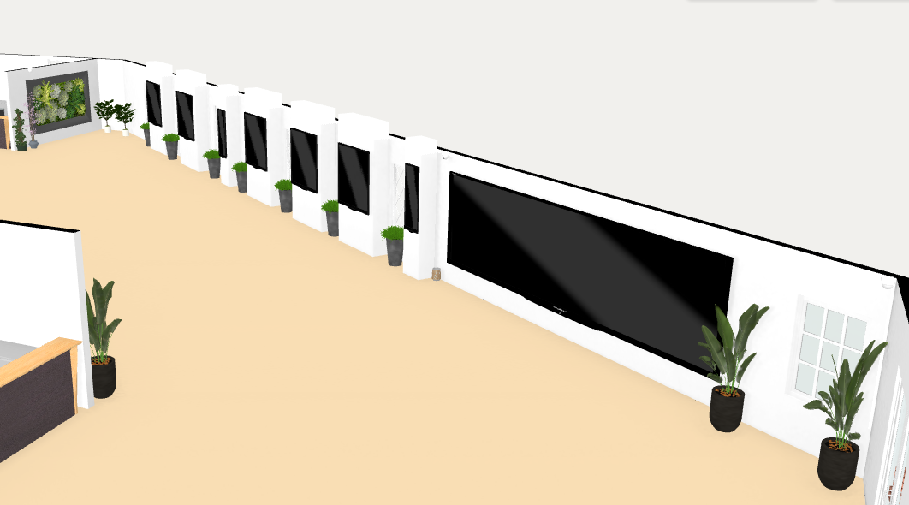

Figure 6 Kiosk Station 3D View

Dining Area

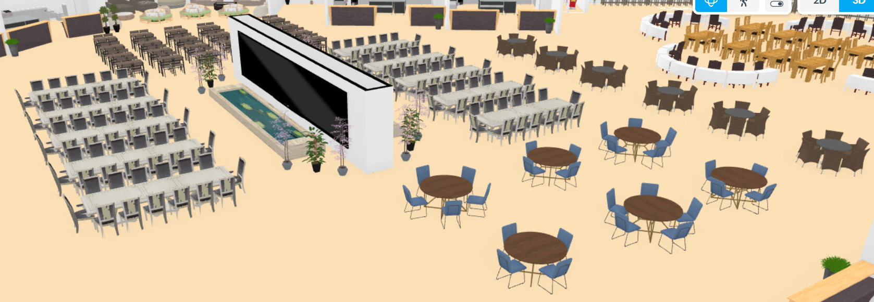

Figure 7 Dining Area 3D View

Kitchens

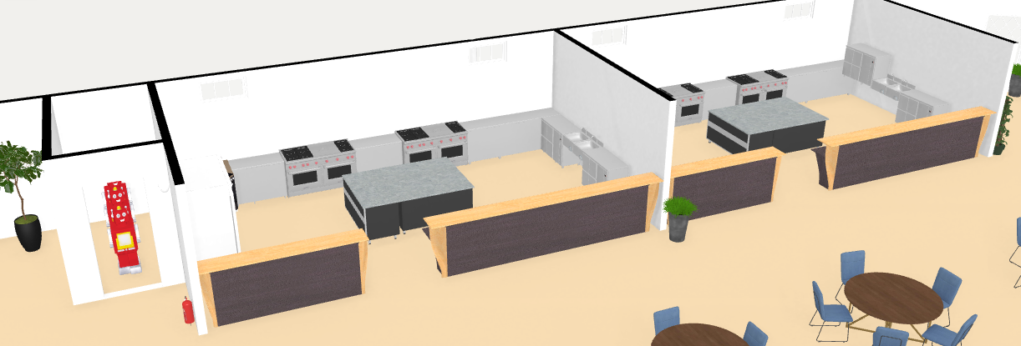

Figure 8 Kitchen 1 3D View

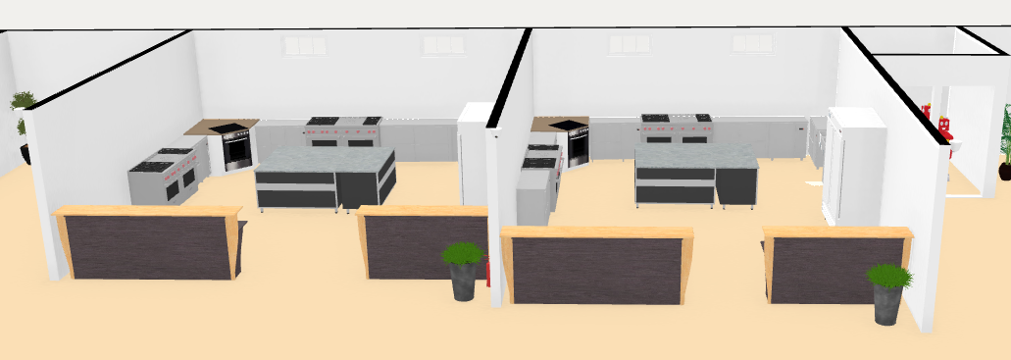

Figure 9 Kitchen 2 3D View

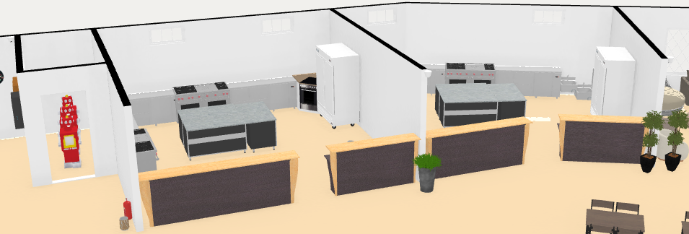

Figure 10 Kitchen 3 3D View

Lounge Area

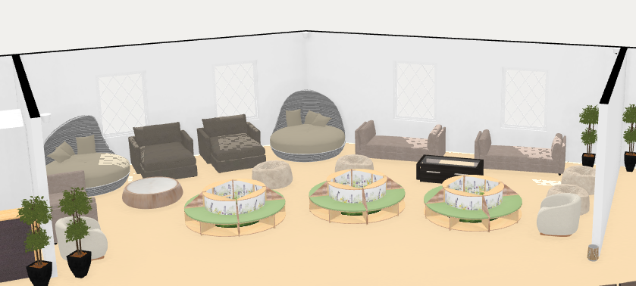

Figure 11 Lounge Area 3D View

Assignment Corner / Dining Area

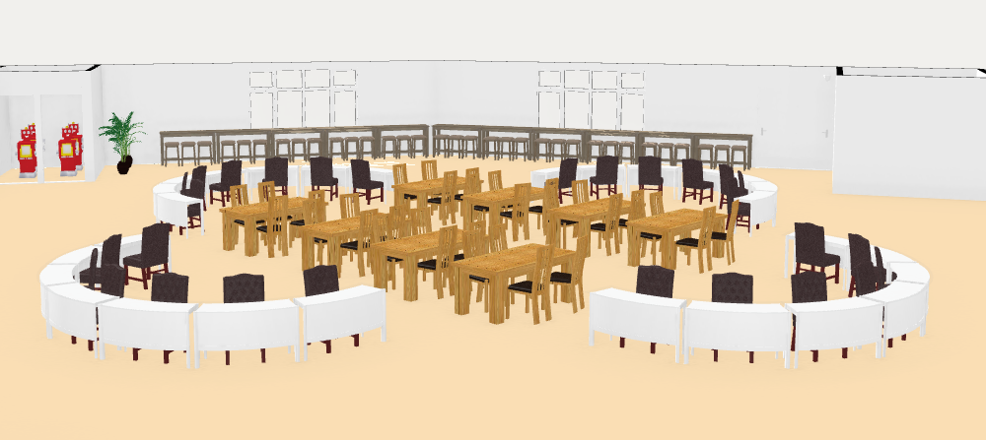

Figure 12 Assignment Corner 3D View

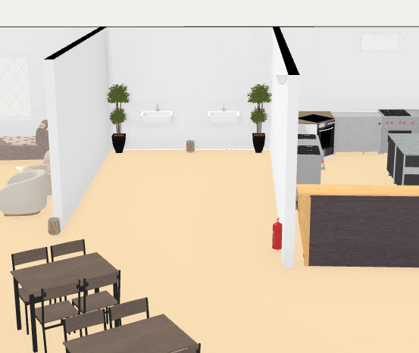Hand Wash Stations

Figure 13 Handwash Station 2 3D View

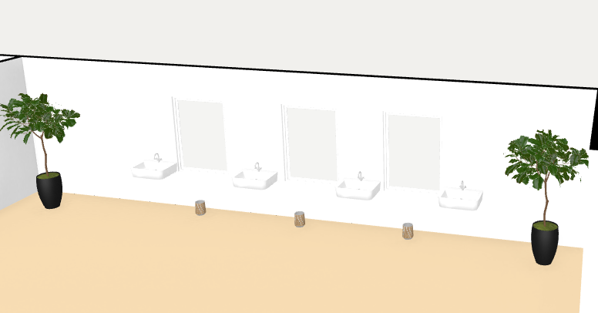

Figure 14 Handwash Station 1 3D View

Toilets

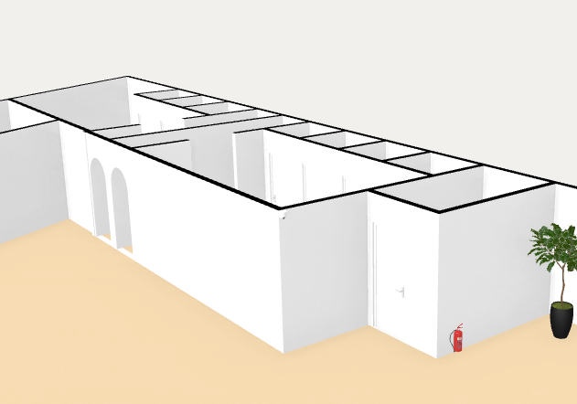

Figure 15 Toilet 3D View 1

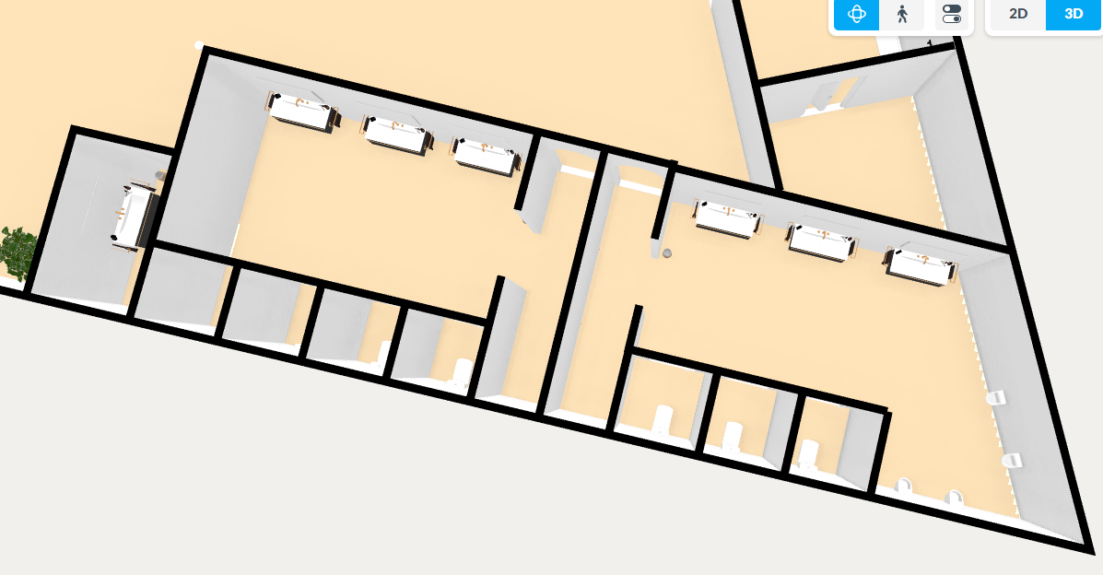

Figure 16 Toilet 3D View 2

Surau

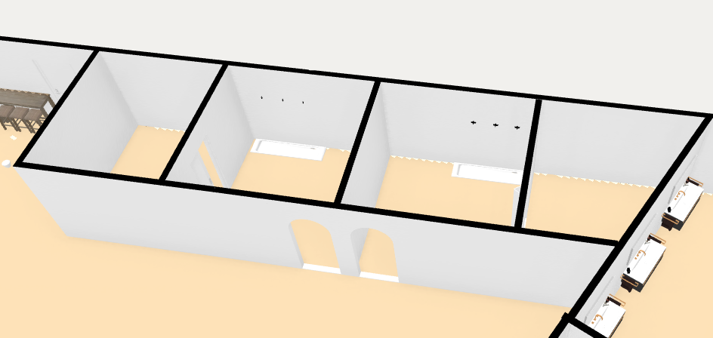

Figure 17 Prayer Room 3D View

Safety Features

Emergency Exit

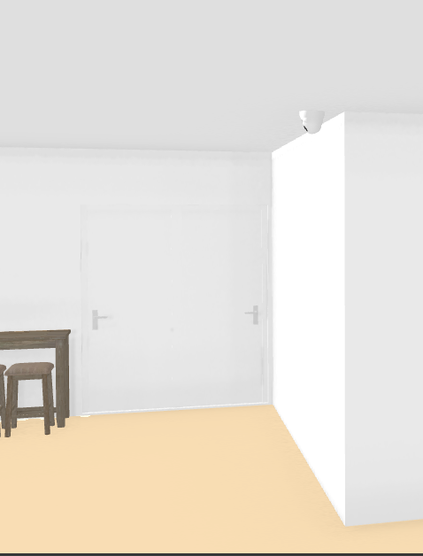

Figure 18 Emergency Exit 3D View

CCTVs

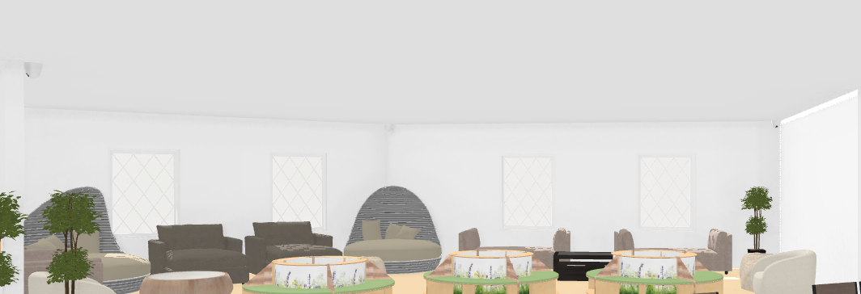

Figure 19 CCTV's 3D View

Fire Extinguishers

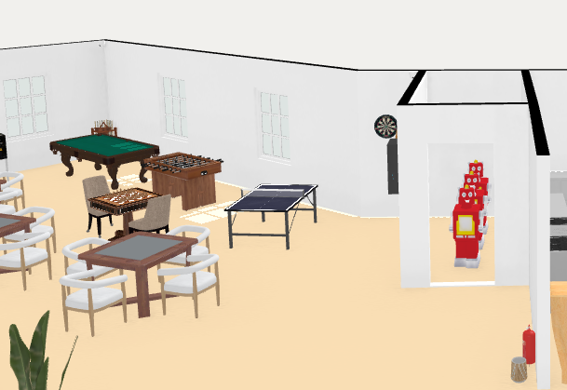

Figure 20 Fire Extinguisher 3D View

# Work Breakdown Structure (WBS)

Work breakdown structure is a deliverable-oriented hierarchical decomposition of the work to be executed by the project team, defined by Project Management Book of knowledge (PMBOK) published by the Project Management Institute (PMI). Work breakdown Structure is considered one of the most important project management documents, involving the project's total scope. Any work not involved in the WBS is not in the project (Organ and Bottorff, 2024).

There are several reasons that show the work breakdown structure is useful for project management. First, WBS breaks the required work of the project into smaller tasks, which make the project more manageable. Second, WBS is a roadmap for different individuals and teams that are working on the project. Most of the projects involve different teams, these teams need to cooperate with each other so that the project can be completed. By using WBS, each team can have a clear understanding of their task in the project. Lastly, WBS shows how the project will be done, therefore it can be used for measuring the project completion.

There are two main types of WBS which are deliverable-based WBS and phase-based WBS (Work Breakdown Structure (WBS): The Ultimate Guide (with Examples), 2024). The main difference between these two types of WBS is that the project is divided according to the time or scope. Deliverable-based WBS focuses on the project outcome, while phase-based WBS organizes the project according to the project phases.

Deliverable-based WBS first divides the project into more specific deliverable or components. Each of these components is the necessary output that should be done for the final product. Deliverable-based WBS is commonly used when some requirements are emphasized to be completed for the product. However, phase-based WBS divide the final deliverable into different phases. Each phase includes a specific task to be done before moving to the next phase. Phase-based WBS is useful when the project is process oriented.

In this case, the project is about to build and design a new cafeteria at Asia Pacific University. Therefore, phase-based WBS has been decided to use as it is more convenient to check and review the construction's progress. Figure shows the work breakdown structure of the cafeteria.



Figure 21 WBS Diagram

**EXPLANATION OF THE WBS**

1. Project Initiation

Project initiation is the first step of starting a new project. It includes three subsequent levels which are to define project scope, define project plan, and obtain plan and budget approval.

* **1.1 Define Project Scope**

Project Scope is to define the goal, deadline and project deliverable.

* **1.2 Define Project Plan**

Project plan is a formal document that outline the execution and control stage of the project.

* **1.3 Obtain Plan and Budget Approval**

Literally, this is the stage to obtain the plan and budget approval

2. Site Selection

Site selection is known as the process of evaluating the advantages and disadvantages between the different locations. It involves three main steps, select a location, site survey, obtain permit and approval.

* **2.1 Select Location**

This step is to select the location for the project.

* **2.2 Site Survey**

Site survey is to inspect the selected location and collect the information for a design.

* **2.3 Obtain Permit and Approval**

Obviously, this step is to obtain the permit and approval for implementing the project on the selected location.

3. Design and Planning

Design is the process of creating a new facility commonly presented by detailed plan and specification. However, planning is the process of determining the task and material needed to make the design to be implemented.

* **3.1 Architectural Design**

This is the process of designing and planning structure emphasizing both aesthetics and usefulness. It can be divided into three parts: layout design, interior design and exterior design.

* + **3.1.1 Layout Design**

The is the process of creating a scale diagram of a region as seen from above, which is usually called floor plan.

* + **3.1.2 Interior Design**

Interior design is the process of designing an indoor space to be functional, safe and beautiful.

* + **3.1.3 Exterior Design**

Like interior design, exterior design is the process of designing the exterior of a building.

* **3.2 Structural Engineering**

Structural engineering is the branch of civil engineering involving the structural design of human-made structures.

* **3.3 Electrical and Plumbing Design**

Electrical design is the process of conceiving and planning system where current flow to carry out a certain task. However, plumbing design is to plan a system of pipe that maintains the flow of water into and out of the building.

* **3.4 Heating, Ventilation and Air Conditioning (HVAC) Design**

This is the engineering of planning the heating, ventilation and air conditioning system in a building.

* **3.5 Safety and Compliance Planning**

This is the process of planning the rules and regulation that related to health and safety in the workplace

4. Site Preparation

Site preparation is known as the process of getting a site ready for upcoming construction work. It involves four parts, which are soil testing, land clearing and grading, utility connection, and site access road and temporary facilities.

* **4.1 Soil Testing**

Soil testing is to measure the soil’s ability which helps ensure the performance and stability of constructed structure throughout the long run.

* **4.2 Land Clearing and Grading**

This is the first step of any construction project which provides a reliable foundation for any building.

* **4.3 Utility Connection**

Utility connection is one of the important components when building a new facility, which involves water supply, electricity, and sewerage system.

* + **4.3.1 Water Supply**

This is known as the process of supplying water to the location.

* + **4.3.2 Electricity**

This is known as the process of providing electrical power to the location.

* + **4.3.3 Sewerage System**

A sewerage system is used to collect wastewater.

* **4.4 Site Access Road and Temporary Facilities**

Temporary Site Access Road provides access to those heavy construction vehicles that have carried the needed materials and equipment for the construction. Temporary facilities are set up temporarily for the construction site which can provide flexibility and convenience solution.

5. Foundation and Structural Work

This process is known as fixing part of the building into the soil, which supports the main structures. It can be divided into four parts, which are excavation for foundation, foundation construction, structural framework, and concrete and masonry work.

* **5.1 Excavation for Foundation**

This is the process of removing dirt from the allotted area to provide space for the foundation.

* **5.2 Foundation Construction**

After excavation, the structure's foundation can be connected to the ground. It can be divided into footings and slab on grade.

* + **5.2.1 Footings**

This is the bottom part of the foundation. It is one of the crucial parts in foundation as it distributes the weight of the whole structure evenly which prevents the entire building sinking into the ground.

* + **5.2.2 Slab on grade**

This is the process of placing a concrete slab on the ground. It serves various functions, such as supporting other building elements, distributing the weight of the building etc.

* **5.3 Structural Framework**

Structural framework is used for resisting the lateral and gravity loads, it involves column and beam, and roof structure.

* + **5.3.1 Column and Beam**

Beams are used to transmit the total loads from the slab to the column. Next, columns will carry it to the foundation which ensures the stability of the structure.

* + **5.3.2 Roof Structure**

Roof structure is designed to support the roof of the building

* **5.4 Concrete and Masonry Work**

Concrete work is the process of mixing cement, sand, small stone and water together. It supplies the material needed for masonry work. However, masonry work is using concrete, brick, stone and others, to construct the buildings.

6. Building Construction

This is the process of making the structure or building to be real property. It can be divided into wall construction, roof installation, windows and door installation, electrical and plumbing rough-in, HVAC system installation, and insulation and waterproofing.

* **6.1 Wall Construction**

Wall construction is the process of partitioning area by area. It can be divided into exterior wall and interior partition.

* + **6.1.1 Exterior Wall**

This is the process of constructing the wall outside of the building

* + **6.1.2 Interior partition**

This is the process of dividing the internal area of the building.

* **6.2 Roof Installation**

Roof installation is known as the process of constructing the cover of the building

* **6.3 Windows and Door Installation**

This is the process of installing the windows and door to the building

* **6.4 Electrical and Plumbing rough-in**

Rough-in is the stage of bringing in the various electrical and plumbing line.

* + **6.4.1 Electrical Wiring**

Electrical rough-in is the process of pulling wiring, installing junction boxes etc.

* + **6.4.2 Plumbing Line**

Plumbing rough-in is the process of installing the main pipes and other components of the plumbing system.

* **6.5 HVAC System Installation**

This is the process of installing the heating, ventilation and air conditioning system.

* **6.6 Insulation and Waterproofing**

Making the building have high-quality waterproofing and insulation can make it perform in good condition in the long run.

7. Interior Construction

Interior construction is known as the process of transforming the inner shell of the building. It can be divided into floor installation, wall finishing, celling installation, lighting installation, final electrical and plumbing connections, kitchen equipment installation, table sand chair installation, and safety and health features installation.

* **7.1 Floor Installation**

Floor installation is the process of applying a finish material over the floor structure to provide a walking surface

* **7.2 Wall Finishing**

Wall finishing is applying the interior walls with a final layer or coating

* + **7.2.1 Painting**

This is known as applying the wall with desired color.

* + **7.2.2 Tiling**

This is the process of covering the walls with tiles.

* **7.3 Ceiling Installation**

This process involves hanging, cutting and finishing ceiling materials which also need to ensure that the ceiling is well installed and secure

* **7.4 Lighting Installation**

This is the process of installing the lighting system in the building.

* **7.5 Final Electrical and Plumbing Connections**

This step ensures all the lights, control circuit, and others appliance are powered by the electrical system. In addition, it also guarantees the supply of water and drainage of wastewater are provided properly by plumbing system.

* **7.6 Kitchen Equipment Installation**

This is the process of installing the kitchen equipment, such as sink, counter-top, stove, electric flying pans etc.

* **7.7 Table and Chair Installation**

This includes putting the table and chair so that people can have a comfortable place to enjoy their food.

* **7.8 Safety and Health Features Installation**

This process involves setting up the systems or equipment that ensure the safety and well-being of an individual. These features protect the user from hazards, prevent accidents and promote overall health. It can be sanitation stations, ventilation and air quality control, security systems etc.

8. Exterior Construction

Exterior Construction is the process of transforming the external environment of a building. It can be divided into exterior finishing, landscaping, walkway and access path, and outdoor lighting installation.

* **8.1 Exterior Finishing**

This is the process of applying an outside covering on the building which can protect the structure against the outside weather.

* **8.2 Landscaping**

This is the process of adding plants around the building which can provide people the healthy breath and a good appearance.

* **8.3 Walkway and Access Path**

This is the process of creating a path for people to access the building.

* **8.4 Outdoor Lighting Installation**

This includes installing the lights around the building to maintain the visual performance of people.

9. Technology Integration

This is the process of adding innovative technology designed to the cafeteria. It involves installation of QR code ordering system, setup of robot waiter system, installation of table finding software, and IT infrastructure setup.

* **9.1 QR Code Ordering System**

This involves placing the QR code at each table inside the cafeteria. These QR codes can only be scanned using the APSpace software, allowing customers to order food. Besides, the system will automatically deduct the balance from the APCard based on the price of the ordered food price through the APSpace software.

* **9.2 Setup of Robot Waiter System**

This process involves adding robot waiters to the cafeteria. It involves mapping setup, integration with order system, and testing and calibration. The robot waiters help prevent people from walking around the cafeteria, reducing congestion. Instead of picking up their food after ordering, customers will have their food delivered by the robot waiter.

* **9.3 Installation of Table Finding Software**

This process involves installing sensors and lights above the tables. A green light indicates the table is available, while a red light signals that it is occupied. In addition, real-time table availability will be displayed in the APSpace software, allowing customers to find an empty table without walking around the cafeteria.

* **9.4 IT Infrastructure Setup**

IT infrastructure includes two core elements: hardware and software. This process involves installing the hardware and integrating it with the software. It consists of two main components: Wi-Fi installation and security system.

* + **9.4.1 Wi-Fi Installation**

This process ensures that the entire premises are covered with high-speed internet access by strategically placing wireless access points to provide consistent and reliable connectivity.

* + **9.4.2 Security System**

This process includes the installation of sensor-based devices that can detect intrusion or unauthorized use of equipment.

10. Safety and Compliance

This process ensures that the cafeteria adheres to all relevant safety standards, building codes, and regulatory requirements. It includes fire safety system installation, health and safety inspection, building code compliance check, and environment compliance.

* **10.1 Fire Safety System Installation**

This process includes equipping the cafeteria with a system that prevents fires and protects people in case of a fire emergency.

* **10.2 Health and Safety Inspection**

This process includes inspecting to ensure the completed cafeteria meets all health and safety standards.

* **10.3 Building Code Compliance Check**

This activity's purpose is to verify that all aspects of the cafeteria comply with local, regional, and national building codes.

* **10.4 Environmental Compliance**

This process ensures that the cafeteria minimizes its environmental impact and complies with environmental laws and regulations.

11. Final Inspection and Handover

This process includes conducting a final inspection of all equipment to ensure everything is functioning properly. Once all equipment is verified to be in working order, the cafeteria is ready for handover to the client.

* **11.1 Final Building Inspection**

This step includes reviewing the entire building to ensure it meets all regulatory, safety, and construction standards.

* **11.2 System Testing and Commissioning**

This phase includes testing all the major systems of the cafeteria. It can be electrical system, plumbing system, HVAC system, and technology system.

* + **11.2.1 Electrical System**

This process ensures all the electrical wiring, lighting and power system are installed safely and operating perfectly.

* + **11.2.2 Plumbing System**

This process involves testing the plumbing fixture and pipelines to ensure proper water flow and drainage.

* + **11.2.3 HVAC System**

In this process, the heating, ventilation, air conditioning system is tested for proper climate control, air circulation and energy efficiency.

* + **11.2.4 Technology System**

This process involves testing all the QR code ordering system, robot waiters, and table finding software and security systems.

* **11.3 Handover to Client**

Once all the final inspections are completed, the project is handed over to the client.

12. Project Closeout

Project Closeout is the process of ensuring all the project-related documentation, finances and reviews are finalized.

* **12.1 Final Documentation and As-Built Drawings**

This step involves finalizing and organizing all the project-related documents for the client. As-built drawings are drawings that show how the cafeteria was built.

* **12.2 Financial Closeout**

This process involves finalizing all the financial aspects of the project and ensuring that all the payments are made.

* **12.3 Post-Construction Review**

This process includes evaluating the entire project’s success and identifying lessons learned.

* **12.4 Project Sign-Off**

This is the formal closure of the project, where the client officially accepts the completed cafeteria, and all parties sign off on the project.

# Network Diagram

A network diagram is one of the most essential parts of engineering project management. This is due to several reasons:

**Visual representation of the activities**: A network diagram makes it easier for the project members to visualize all the activities and tasks and how they are dependent on each other.

**Critical path**: The network diagram is a powerful tool to identify the critical path. With this knowledge in hand, project managers are able to prioritize the more important activities to ensure that the project stays on track.

**Risk management**: Knowing how each activity are interconnected to each other, the project manager can identify the potential risks and avoid them if possible.

**Improving teamwork**: By clearly knowing how the tasks are connected to each other, the team members can communicate better. This will ensure that everyone is well aware of their responsibilities.

On of the most effective ways to draw the network diagram is using PDM. PDM stands for the Precedence Diagram Method. In this method, each node represents an activity. Arrows are used to show how the activities depend on each other. To construct the network diagram using PDM node, first, a table of activities is created to arrange all activities.

|  |  |  |  |
| --- | --- | --- | --- |
| **Activity ID** | **Activity name** | **Preceding Activity** | **Duration (Days)** |
| **A** | **Project Initiation** |  |  |
| A1 | Define Project Scope | Start | 1 |
| A2 | Define Project Plan | A1 | 5 |
| A3 | Decide Project Schedule | A2 | 1 |
| A4 | Obtain plan and budget approval | A3 | 3 |
| **B** | **Site selection** |  |  |
| B1 | Select location | A4 | 7 |
| B2 | Site Survey | B1 | 2 |
| B3 | Obtain permits and approvals | B2 | 5 |
| **C** | **Design and Planning** |  |  |
|  | **Architectural design** |  |  |
| C1 | Layout design | B3 | 20 |
| C2 | Interior design | C1 | 14 |
| C3 | Exterior design | C1 | 15 |
|  | **Security and Safety** |  |  |
| C4 | HVAC design | C2, C3 | 7 |
| C5 | Structural engineering | C2, C3 | 10 |
| C6 | Electrical and plumbing design | C2, C3 | 7 |
| C7 | Safety and compliance planning | C2, C3 | 7 |
| **D** | **Site preparation** |  |  |
| D1 | Soil testing | C4, C5, C6, C7 | 2 |
| D2 | Land clearing and grading | D1 | 10 |
| D3 | Water supply system connection | D2 | 14 |
| D4 | Electricity system connection | D2 | 14 |
| D5 | Sewerage system connection | D2 | 15 |
| D6 | Site access and workers' temporary facilities | D3, D4, D5 | 5 |
| **E** | **Foundation and structural work** |  |  |
|  | **Foundation construction** |  |  |
| E1 | Footing construction | D6 | 14 |
| E2 | Slab on grade construction | E1 | 7 |
|  | **Structural framework** |  |  |
| E3 | Column and beam construction | E2 | 20 |
| E4 | Roof construction | E3 | 10 |
| E5 | Concrete and masonry work | E4 | 15 |
| **F** | **Building Construction** |  |  |
|  | **Wall construction** |  |  |
| F1 | Exterior wall construction | E5 | 20 |
| F2 | Interior wall construction | F1 | 10 |
| F3 | Roofing installation | F2 | 7 |
| F4 | Window and door installation | F3 | 5 |
|  | **Electrical and Plumbing Rough-In** |  |  |
| F5 | Electrical wiring | F4 | 10 |
| F6 | Plumbing line installation | F4 | 7 |
| F7 | HVAC system installation | F4 | 7 |
| F8 | Insulation and waterproofing | F5, F6, F7 | 2 |
| **G** | **Interior construction** |  |  |
| G1 | Floor installation | F8 | 3 |
| G2 | Wall painting and tiling | G1 | 5 |
| G3 | Lighting installation | G2 | 2 |
| G4 | Electrical and plumbing connection | G3 | 5 |
| G5 | Kitchen equipment installation | G4 | 7 |
| G6 | Furniture installation | G4 | 5 |
| G7 | Safety and Health Feature Installation | G4 | 3 |
| **H** | **Exterior Construction** |  |  |
| H1 | Exterior finishing | G5, G6, G7 | 5 |
| H2 | Landscaping | H1 | 5 |
| H3 | Walkway and access path construction | H2 | 25 |
| H4 | Outdoor lighting installation | H3 | 1 |
| **I** | **Technology integration** |  |  |
| I1 | Installation of QR code ordering system | H4 | 1 |
| I2 | Setup of robot waiter system | H4 | 2 |
| I3 | Installing of table finding software | H4 | 1 |
|  | **IT infrastructure setup** |  |  |
| I4 | Wifi installation | I1, I2, I3 | 1 |
| I5 | Security system | I1, I2, I3 | 2 |
| **J** | **Safety and Compliance** |  |  |
| J1 | Fire safety system installation | I4, I5 | 1 |
| J2 | Health and safety inspection | J1 | 1 |
| J3 | Building code compliance check | J1 | 2 |
| J4 | Environmental compliance check | J1 | 1 |
| **K** | **Final inspection and handover** |  |  |
| K1 | Final building inspection | J2, J3, J4 | 2 |
|  | **System testing and commissioning** |  |  |
| K2 | Electrical system check | K1 | 2 |
| K3 | Plumbing system check | K1 | 1 |
| K4 | HVAC system check | K1 | 1 |
| K5 | Technology system check | K1 | 1 |
| K6 | Handover to client | K2, K3, K4, K5 | 1 |
| **L** | **Project closeout** |  |  |
| L1 | Final documentation | K6 | 3 |
| L2 | Financial closeout | K6 | 2 |
| L3 | Post-construction review | L1, L2 | 7 |
| L4 | Project sign-off | L3 | 1 |

## PDM Network Diagram

The complete PDM network diagram can been seen on the following page.

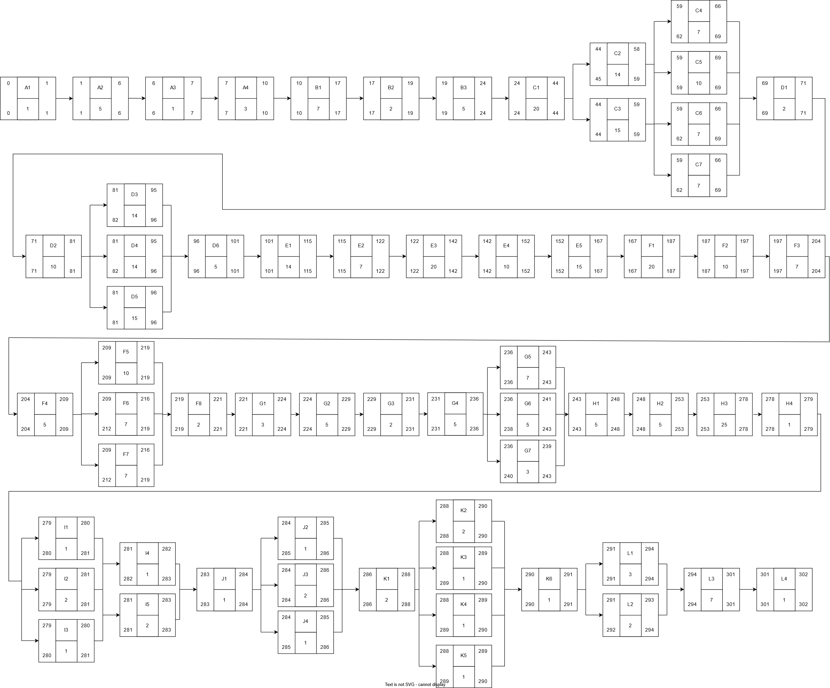

To better comprehend the PDM diagram, we can analyze it by dividing it into smaller sections. 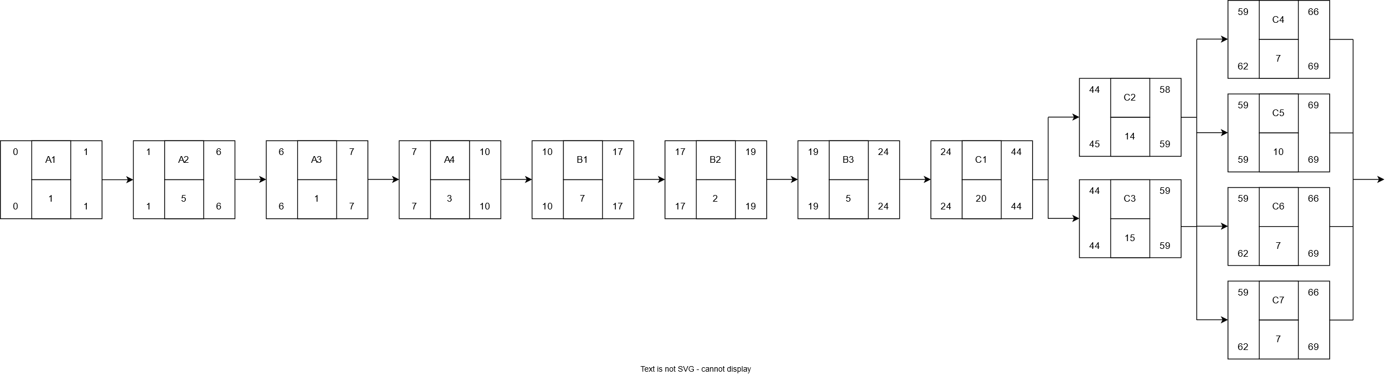

Figure 22 PDM Diagram Section 1

The above image represents the subsections A, B and C. All these activities are to be conducted before any sort of construction starts on the site.

Part A is the project initiation which will take 10 days in total. This period will compromise activities such as defining the project scope (A1), project plan (A2), project schedule (A3) and obtaining approvals (A4) which should take 1, 5, 1 and 3 days respectively.

In section B, the team will decide on selecting the site. B1 represents selecting a location among all the available sites. This is estimated to take around 7 days. After selecting the desired location, it is necessary to perform a proper site survey (B2) which should be completed in 2 days. To build something at the site, it is important to obtain all permits and approvals (B3) which should take about 5 days.

Part C is one of the most essential parts of building the cafeteria. The first step would be to design the layout (C1), which is estimated to take 20 days. The exterior (C3) and interior (C2) design are equally important and can be started once the layout design is completed. They can work together and finish both designs in 2 weeks. Other aspects of design that need to be considered are the HVAC design (C4), structural design (C5), electrical and plumbing design (C6). These can be performed after the interior and exterior designs have been completed and should take 10 days to finalize. Consequently, the safety and compliance planning (C7) have to be done to ensure that the building is safe and habitable.

In total, part A, B and C will take 69 days to complete. 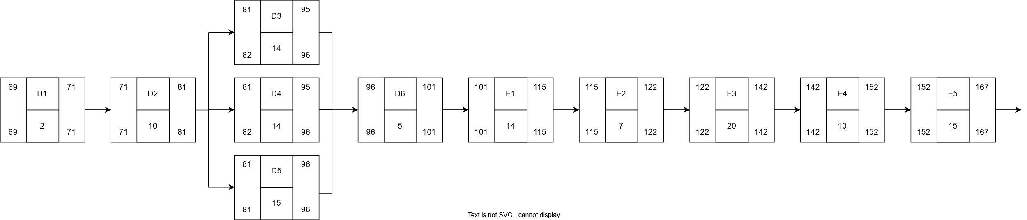

Figure 23 PDM Diagram Section 2

The above image shows the second subsection of the network diagram which consists of parts D and E.

The most essential activity that needs to be conducted before any construction begins is soil testing (D1). This is to ensure that the land we are building on is able to withstand the structure. This step is estimated to take 2 days. After the land has been tested, land clearing and grading (D2) is conducted to prepare the site for construction. This will take 10 days to finalize. Water supply system connection (D3), electricity system connection (D4), sewage system connection (D5) needs to be initiated so that the building has the basic utilities. This step is estimated to take 15 days in total when all activities are conducted together. Workers’ facilities are necessary to ensure that the construction takes place in a safe and orderly manner. Therefore, activity D6 is carried out where site access and temporary facilities are provided to the construction workers. This setup will take 5 days.

In part E, the foundation and structural work is carried out. E1, the footing construction will take 14 days. After the foundation is completed, slab on grade construction (E2) is to be carried out in 7 days. After the base has been made, column and beam construction (E3) is to be carried out and completed in 20 days. This is followed by the roof construction (E4) which takes a period of 10 days. Consequently, concrete and masonry work (E5) is conducted in 15 days.

Therefore, it should take 167 days to complete activities till part E.

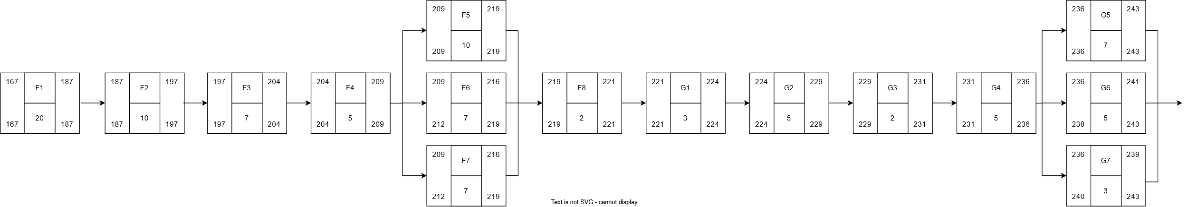Parts F and G of the project will be carried out. In this phase, the building will start taking shape.

Figure 24 PDM Diagram Section 3

Firstly, activity F1 will be carried out where the exterior walls will be constructed. This has been allocated 20 days to be conducted. Next interior walls will be built (F2) which will take around 10 days as there are not a lot of interior walls in our cafeteria. The roof will be built (F3) in a week. After this, the main structure of the cafeteria will be successfully completed. Next, the windows and doors will be installed in 5 days’ time. Activities F5, F6 and F7 – electric wiring, plumbing line installation and HVAC system installation – will be carried out at the same time. The electrical wiring is expected to take slightly more time than the other 2. Therefore, 10 days have been allocated to it, of which 7 days have been given to the other two. Insulation and waterproofing are a very important step for the safety of the cafeteria and will be conducted in 2 days.

Activities under G will follow which compromise of interior construction. G1, floor installation will take 3 days. After the floors have been installed, wall painting in the cafeteria and tiling in all the kitchens (G2) will be done in 5 days. Lighting (G3) will then be installed and is estimated to take 2 days. Other electrical sockets and plumbing connections (G4) will follow and are allocated 5 days. Next, some features and necessities in the cafeteria will be installed. These activities can be carried out altogether. The kitchen equipment (G5) will be installed and is expected to be concluded in 7 days. At the same time, all the furniture of the cafeteria (G6) and safety and health features (G7) like the fire extinguishers, first aids etc., are expected to be installed in 3 days.

In conclusion, the project will take 243 days to reach till part G.

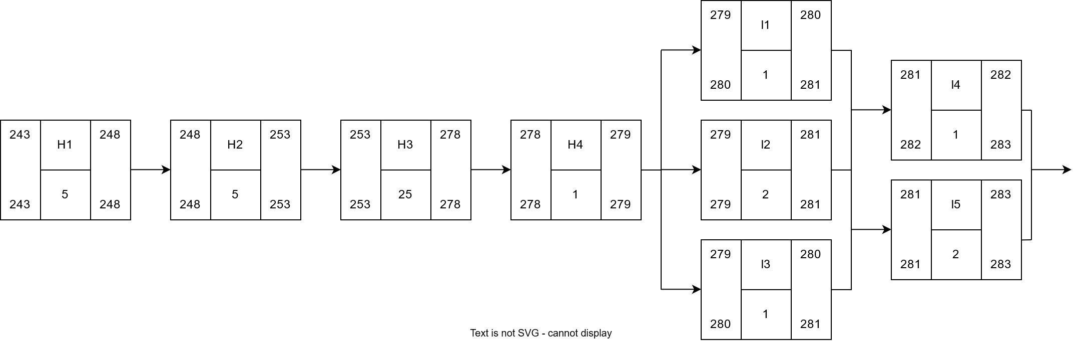Subsequently, part H and I will be started. Above, the network diagram for the two parts has been given. In part H, the exterior construction will begin. First, the exterior finishing (H1) will take place where all the walls will be painted and cleanup around the area will take place. This will be done in 5 days. Landscaping (H2) is expected to take place in 5 days where the exterior environment will be made more pleasant. The other big part of construction, the walkway that connects the university campus to the cafeteria will begin its construction (H3). Since this is a big construction too, it has been allocated 25 days to successfully be built. Once that has been completed, activity H4 will be carried out where outdoor lighting will be installed. This should take no more than a day.

Figure 25 PDM Diagram Section 4

After the larger constructions have been completed, a few smaller tasks are left. Activity I deal with the technology integration on the campus. The QR code ordering system (I1) is installed for the cafeteria. Since it is a basic installation, this can be done in a day. The robot waiter (I2) which is a standout feature of our cafeteria is then installed. Since this requires a lot of calibration and setup, 2 days have been allowed for this system to be successfully installed. Activity I3, which is the installation of the table finishing software, is expected to take a day. Since I1, I2, and I3 and tasks that are not dependent on each other, they are expected to be carried out together at the same time. This not only increases efficiency but also saves time on the project. After these activities are done, the Wi-Fi (I4) and security (I5) system is installed which will take 1 and 2 days respectively. Again, these will be carried out at the same time.

After these activities, the construction and installation part of the cafeteria has been completed successfully. This is approximated to take around 283 days.

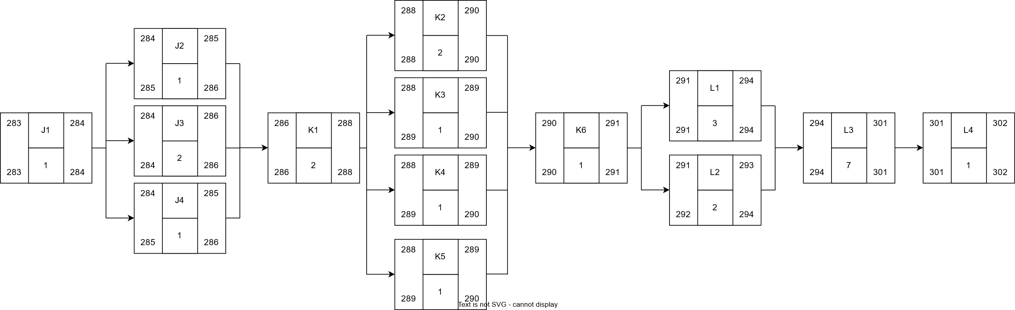Activities J, K and L are post construction activities. They form the final stages of the project. The above PDM diagram deals with these 3 activities.

Figure 26 PDM Diagram Section 5

Part J deals with checking if the cafeteria is safe to use and is up to code. J1 deals with the installation of sprinklers and smoke detectors etc., for fire safety and is expected to take a day since it is basic installation. After all the necessary equipment has been installed, inspections will take place by officials. Activities J2, J3 and J4 – health and safety inspection, building code compliance check, and environmental compliance check – will take place together. building code compliance is expected to take slightly longer than the other two and therefore has been given 2 days, in contrast to the rest.

After this, activity K will be initiated. Here, the building will be checked again a final time (K1) to ensure nothing has been overlooked. This is allocated 2 days. After this, the electrical system (K2), plumbing system (K3), HVAC system (K4) and technology system (K5) will all be checked to see if they work flawlessly. The electrical system check is allocated 2 days, and the rest have been given a day. They will all be done together. After this, activity K6 will be carried out where the project will finally be handed over to the client.

After the handover, there are still some tasks to finish to properly conclude the project. Task L1 involves writing detailed documentation and logging all details of the projects. This is to ensure that everything has been recorded properly and the team cannot be held responsible for anything that is not their fault. This is expected to take 3 days so that nothing is overlooked. Next, activity L2 which is a critical part of the project takes place. Here, the financial closeout signifies the end of all financial activities of the project. This will take 2 days to properly finish. A key characteristic of a good company is their customer service. The customer is given a week to observe and raise complaints. This is the post-construction review (L3). Finally, when no complaints are raised, activity L4, the project sign off represents the end of the project. Thus, in 302 days, the project can be successfully finished.

# Critical Path:

To utilize the PDM (Precedence Scheduling Method) nodes displayed in the table, six discrete pathways are delineated, each having a variable duration. Each path included a number of tasks to do, all of which were added to the project's final deadline. Path 2, the shortest of all, took 293 units to finish, while Path 1, the longest, took 294 units. Path 3 was the fastest of all the pathways, requiring just 287 units. With a length of 302 units, Path 4 was the vital path that was going to determine the project's completion. Path 5 and Path 6 took 293 units apiece, the same amount of time. The key path, or Path 4, is ultimately where you should concentrate because any delays here will affect the project's overall timetable. Since this path is crucial to the success of the project, it must be constantly watched to make sure it continues in the right direction.

From the facts as presented in the table below, “Path 4” which took 302 days was identified to be the critical path. The total path length was estimated by summing up the time that each event of the path has taken to be advanced. Every activity on this chain has an impact on the duration of a project; the critical path shows the maximum time a project could take. As the computations in the table show, some of the same values are the key route calculations across many pathways and paths. Therefore, the time limitation is established once the most critical path out of all the paths have been identified and the maximum amount of time required to complete the project is stated. The overall project will be immediately affected by any theses in the activities along this line of work. This can be combatted however in the following methods: Starting work earlier, or/and to getting the most out of them. For instance, if activities C5 and D6 are completed before time (say, by condensing time for these activities from 7 to 5 days), Path 4 will take lesser number of days, thus allowing for earlier project completion time. In addition, if Path 4 is started earlier, it does not decrease the key path duration, but it makes sure that all the tasks are completed earlier ensuring that the project is delivered on the agreed time. Moreover, with early beginnings, management acquires the freedom to shift resources and time, and thus they can avert future problems of scheduling such as scarce resources or national holidays. When two projects are in the same business line bidding for the same resources is to follow two different courses of action early planning and changes can help in managing the risks involved and ensuring that important jobs are completed in time. The effective sustaining of critical path management lets the project manager to reduce risks that might lead to delay in the cover while at the same time they use minimal resources to achieve the project, meet deadlines and accomplish the project within the agreed time span.

Table 1 Critical Path

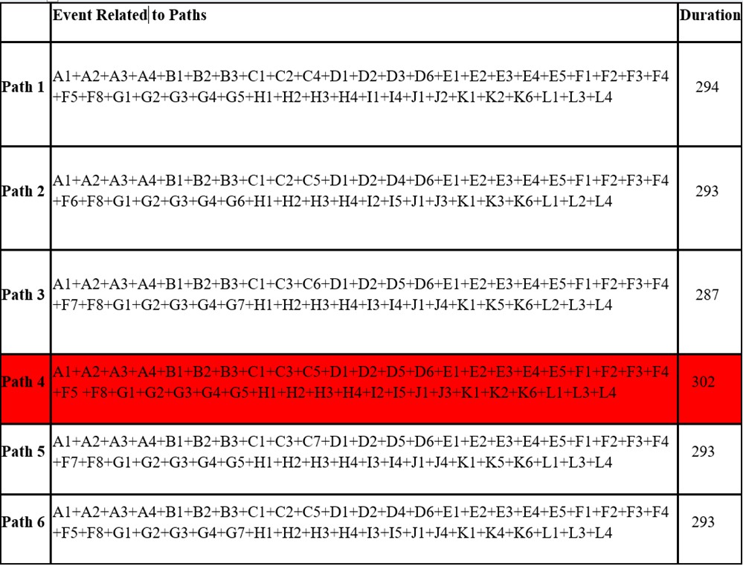

# Gantt Chart:

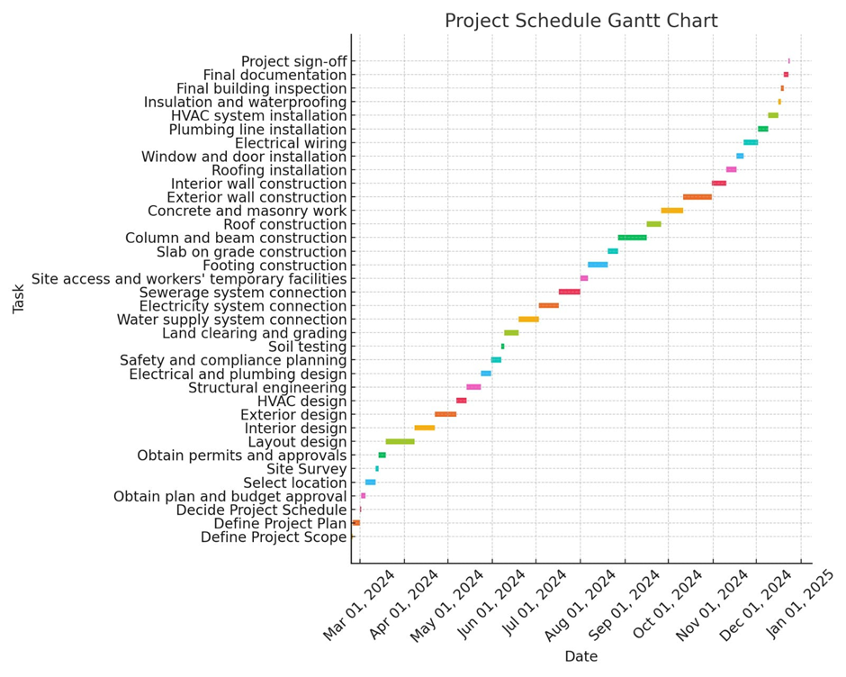

Figure 27 Gantt Chart

The Gantt chart that has been shown here is one of the most detailed project schedules for the construction project. These include listing of every activity, the time it is expected to take together with its start and stop date. The project is separated more broadly, and each of the phases has its name: planning, design, construction, and finalization, the tasks are differentiated according to the timeline from March 2024 till January 2025.

Some of the tasks done in the planning phase include project planning, scheduling definition, layout design and risk management planning phase start from March 1, 2024. It is in this stage that the foundation of the remaining project is set concerning the resources to be used, time and funds to be expended so that the project is taken through the right course.

The design phase commences from March 17, 2024, and entails activities that are, site surveying activity, structural design activity, electricity and water activity and interior as well as exterior activity. These tasks are very important in developing the schedules and other specifics that constitute the plan and blueprints that will be used to implement the construction phase. Construction begins on March 23,

2024 and public works include but not limited to land preparation, soil survey, construction of the under-ground structure and fixing of basic facilities like electricity, water and sewage. This phase goes on with other important construction activities such as wall construction or completion, roofing, plumbing works, installation of electrical wiring, window and door installation among others. All these tasks are important in terms of generating the physical structure of the project that is being developed.  
 Roofing, insulation and waterproofing, installation of the heating, ventilation and air conditioning systems among others will in the process be in progress to ensure that there is proper and adequate protection. Some aspects such as final inspections for observing that all systems meet the set legal prescriptions as well as documentation will take place towards the last part of the project implementation plan.

After all the activities are over only the final project sign-off is expected to be done in January 2025. This Gantt chart can help the project manager to track all the tasks throughout the project and notice delays as well as take corrective action to help the project to stay on track. The chart is also useful in terms of resources, work progress dependency and to ensure that the project will finish on time.

# Cost Estimates

Cost estimation involves predicting the financial resources needed for a project by considering various factors such as labor, materials, equipment, and potential contingencies. This process is essential in project planning and management, as it establishes a realistic budget that informs decision-making, resource distribution, and timelines. Precise cost estimates are crucial in avoiding budget overruns, confirming project viability, and obtaining necessary funding or investment. The significance of cost estimation is evident in its capacity to provide a comprehensive understanding of the financial consequences prior to project initiation. It enables stakeholders to evaluate the project's feasibility, manage expenses, and establish expectations regarding profitability and risk management, ultimately ensuring that the project remains within budget and adheres to the established schedule.

## Labor Cost

Foundation & Structural Work

Table 2 Foundation and Structural Work

|  |  |  |  |  |  |
| --- | --- | --- | --- | --- | --- |
| Labor Task | No.of Workers | Hourly Rate | Days | Total Hours |  |
| Site Preparation Labor | 6 | 30 | 10 | 240 | 43,200.00 |
| Foundation Construction Labor | 6 | 31 | 14 | 336 | 62,496.00 |
| Finishing and Detailing Labor | 4 | 30 | 5 | 120 | 14,400.00 |
| Testing and Commissioning Labor | 2 | 30 | 2 | 48 | 2,880.00 |
| Permits and Inspections | 2 | 30 | 2 | 48 | 2,880.00 |
| Electrical Wiring | 3 | 32 | 10 | 240 | 23,040.00 |
| Plumbing Pipes and Fixtures Installation | 4 | 31 | 7 | 168 | 20,832.00 |
| HVAC Ductwork and Unit Installation | 4 | 30 | 7 | 168 | 20,160.00 |
| Exterior Walls | 5 | 33 | 20 | 480 | 79,200.00 |
| Interior Walls | 3 | 30 | 10 | 240 | 21,600.00 |
| Windows and Doors | 2 | 31 | 5 | 120 | 7,440.00 |
| Total Labor Costs |  |  |  |  | 298,128.00 |

This section provides a comprehensive overview of the labor requirements necessary for foundation and structural work. It encompasses essential activities including site preparation, excavation, formwork construction, rebar placement, concrete pouring, and framing. For each task, the document specifies the number of workers involved, their respective hourly wages, and the total hours needed for completion. Additionally, specialized positions such as electricians, plumbers, and masons are addressed within this section. The overall labor expenditure for the foundation and structural phases of the project totals RM 298,128, highlighting the considerable labor effort essential for maintaining structural integrity and adhering to building regulations.

Interior Construction

Table 3 Interior Construction

|  |  |  |  |  |  |
| --- | --- | --- | --- | --- | --- |
| Task | No. of Workers | Hourly Rate (MYR) | Days | Total Hours | Total Cost (MYR) |
| Electrical Wiring | 2 | 31 | 5 | 120 | 7,440.00 |
| Permits and Inspections | 2 | 34 | 5 | 120 | 8,160.00 |
| Plumbing Pipes and Fixtures Installation | 4 | 32 | 12 | 288 | 36,864.00 |
| Flooring Installation | 5 | 31 | 3 | 72 | 11,160.00 |
| HVAC Ductwork and Unit Installation | 4 | 32 | 10 | 240 | 30,720.00 |
| Total Labor Costs |  |  |  |  | 94,344.00 |

This table outlines the labor necessary for various interior construction activities, such as electrical wiring, plumbing installation, HVAC system configuration, and wall partitioning. It specifies the number of workers allocated to each task, their respective hourly wage rates, and the total hours of labor required. This stage is vital for the safe and efficient installation of the building's internal systems. The total cost for interior construction labor is RM 94,344, which encompasses a variety of skilled labor tasks crucial for making the building operational and livable.

Interior Installations

Table 4 Interior Installations

|  |  |  |  |  |  |
| --- | --- | --- | --- | --- | --- |
| Labor Task | No. of Workers | Hourly Rate (MYR) | Days | Total Hours | Total Cost (MYR) |
| Installation of Stoves | 4 | 20 | 3 | 72 | 5,760.00 |
| Installation of Refrigeration Units | 4 | 30 | 4 | 96 | 11,520.00 |
| Installation of Air Conditioning Units | 4 | 31 | 7 | 168 | 20,832.00 |
| Installation of Lighting and Fans | 4 | 30 | 5 | 120 | 14,400.00 |
| Installation of Cash Registers | 2 | 31 | 3 | 72 | 4,464.00 |
| Installation of Table and Chair Sets | 6 | 32 | 4 | 96 | 18,432.00 |
| Installation of Storage Cabinets | 2 | 30 | 2 | 48 | 2,880.00 |
| Installation of Ceramic Sinks | 2 | 31 | 2 | 48 | 2,976.00 |
| Installation of Washroom Toilets, Sinks, and Dryers | 4 | 30 | 5 | 120 | 14,400.00 |
| Installation of Kitchen Countertops and Sinks | 5 | 30 | 7 | 168 | 25,200.00 |
| Installation of Kitchen Island Table | 4 | 30 | 7 | 168 | 20,160.00 |
| Installation of Kiosks and Top Up Machine | 5 | 30 | 5 | 120 | 18,000.00 |
| Installation of Displays | 4 | 32 | 3 | 72 | 9,216.00 |
| Installation of Sound System | 4 | 31 | 3 | 72 | 8,928.00 |
| Installation of Security Cameras | 4 | 30 | 3 | 72 | 8,640.00 |
| Installation of Entertainment Items | 5 | 28 | 3 | 72 | 10,080.00 |
| Installation of Doors and Windows | 4 | 31 | 5 | 120 | 14,880.00 |
| Total Labor Costs |  |  |  |  | 210,768.00 |

This segment addresses the workforce required for the installation of essential interior fixtures, including kitchen stoves, refrigeration units, air conditioning systems, and furniture. Each installation task outlines the number of personnel needed, their hourly wages, and the total hours necessary for completion. This stage guarantees that the building's interior is operational and furnished with essential appliances and amenities. The overall labor expense for these interior installations amounts to RM 210,768, highlighting the intricacy and extent of the work involved.

Pedestrian Bridge Construction

Table 5 Pedestrian Bridge Construction

|  |  |  |  |  |  |
| --- | --- | --- | --- | --- | --- |
| Labor Task | Number of Workers | Hourly Rate (MYR) | Days | Total Hours | Total Cost (MYR) |
| Laborers | 3 | 29 | 3 | 72 | 6,264.00 |
| Supervisors | 1 | 32 | 3 | 72 | 2,304.00 |
| Total Labor Costs |  |  |  |  | 8,568.00 |

This table presents the labor expenses related to the construction of a pedestrian bridge, highlighting activities such as site preparation, assembly of the steel frame, installation of decking, and the installation of handrails and lighting. The costs encompass both laborers and supervisors to guarantee effective oversight and execution of the project. The construction of the pedestrian bridge necessitates a combination of skilled and semi-skilled labor, culminating in a total labor cost of RM 8,568.

Exterior Finishing

Table 6 Exterior Finishing

|  |  |  |  |  |  |
| --- | --- | --- | --- | --- | --- |
| Labor Task | Number of Workers | Hourly Rate (MYR) | Days | Total Hours | Total Cost (MYR) |
| Pathway | 2 | 30 | 10 | 240 | 14400 |
| Interior furnishing and paint | 4 | 30 | 5 | 120 | 14400 |
| Exterior furnishing and paint | 4 | 30 | 5 | 120 | 14400 |
| Carpet Installation | 2 | 30 | 5 | 120 | 7200 |
| Pedestrian bridge paint | 2 | 30 | 5 | 120 | 7200 |
| Final Inspection & Testing | 2 | 30 | 5 | 120 | 7200 |
| Regulatory Compliance Check | 2 | 30 | 5 | 120 | 7200 |
| Total Labor Costs |  |  |  |  | 72000 |

This segment outlines the labor activities related to the exterior finishing of the project, encompassing tasks such as walkway installation, exterior painting, landscaping, and compliance inspections. These activities are essential for achieving an attractive building exterior that adheres to regulatory standards. The accompanying table details the workforce involved, their hourly wages, and the total hours allocated to these tasks. The overall labor expenditure for exterior finishing amounts to RM 72,000, with a considerable portion allocated to final enhancements and compliance assessments.

TOTAL LABOUR COST = RM 683,808.00

## Raw Material Cost

Pedestrian Bridge Materials

Table 7 Pedestrian Bridge Materials

|  |  |  |  |
| --- | --- | --- | --- |
| Material/Equipment | Quantity | Cost per Unit (MYR) | Total Cost (MYR) |
| Steel | 5 Tons | 3,700 MYR/Ton | 18,500 |
| Bridge Decking and Walkways | 35 Square meters | 100 MYR/Square Meter | 3,500 |
| Handrails and Safety Barriers | 25 Meters (Length) | 100 MYR/Meter | 2,500 |
| Finishes (Paint & Coatings) | 90 Square meters | 18 MYR/Square Meter | 1,620 |
| Lighting and Electrical System | 8 units (Lights) | 50 MYR/Unit | 400 |
| Roofing Materials | 45 Square meters | 27 MYR/Square Meter | 1,215 |
| Miscellaneous | - | - | 2,000 |
| Total |  |  | 29,735.00 |

This table outlines a comprehensive list of the raw materials necessary for building a pedestrian bridge. Essential components consist of structural steel for the framework, decking materials, handrails, lighting fixtures, and support beams. Each item is detailed with its unit price and required quantity, providing an accurate assessment of the materials needed for the bridge. The overall expenditure for these materials totals RM 29,735, guaranteeing the use of high-quality and durable resources in the bridge's construction.

Foundation and Structural Work

Table 8 Foundation and Structural Work

|  |  |  |  |
| --- | --- | --- | --- |
| Material | Quantity | Unit Cost (MYR) | Total Cost (MYR) |
| Concrete | 400 cubic meters | 350 per cubic meter | 140,000 |
| Steel | 40 tons | 2,500 per ton | 100,000 |
| Bricks | 40000 bricks | 0.50 per brick | 20,000 |
| Cement | 50 bags | 20 per bag | 1,000 |
| Sand | 20 cubic meters | 40 per cubic meter | 800 |
| Roofing Steel | 40 tons | 2,500 per ton | 100,000 |
| Total |  |  | 361,800.00 |

The table outlines the essential raw materials needed for the project's foundation and structural elements. Included in this list are concrete for the foundation, steel rebar for reinforcement, bricks, steel beams, and roofing materials. Each item is detailed with its respective quantity and unit price. The overall expenditure for the materials related to foundation and structural work amounts to RM 361,800, reflecting a considerable investment necessitated by the requirement for robust, high-strength materials to guarantee the structure's stability and durability.

Interior Construction & Installation

Table 9 Interior Construction & Installation

|  |  |  |  |
| --- | --- | --- | --- |
| Item | Quantity | Cost per Unit (MYR) | Total Cost (MYR) |
| LED Fixtures | 160 | 210 | 33,600 |
| Electrical Plugs | 120 | 160 | 19,200 |
| Pipes | 200 meters | 30 | 6,000 |
| Fixtures | 15 | 100 | 1,500 |
| Ductwork | 500 meters | 50 | 25,000 |
| HVAC Units | 20 | 5,000 | 100,000 |
| Emergency Lights | 20 | 300 | 6,000 |
| Fire Alarm & Smoke Detectors | 10 | 500 | 5,000 |
| CCTV | 20 | 50 | 1,000 |
| Total |  |  | 197,300 |

This section details the essential raw materials required for interior construction and installation activities, including items like LED lighting fixtures, electrical wiring, plumbing pipes, and HVAC ductwork. The accompanying table lists the unit costs, quantities, and descriptions for each material needed during this project phase. The overall expenditure for materials related to interior construction and installation amounts to RM 197,300, encompassing a diverse array of components vital for equipping the building's interior with operational utilities and systems.

Furniture, Fixtures, and Equipment

Table 10 Furniture, Fixtures, and Equipment

|  |  |  |  |
| --- | --- | --- | --- |
| Component | Quantity | Unit Cost (MYR) | Total Cost (MYR) |
| 5 Piece Table and Chair Set | 24 | 400 | 9,600 |
| 15 Piece Table and Chair Set | 10 | 1700 | 17,000 |
| Round 6 Piece Table and Chair Set | 3 | 500 | 1,500 |
| Round 5 Piece Table and Chair Set | 3 | 400 | 1,200 |
| 5 Piece Table and Chair Set (Wood) | 8 | 350 | 2,800 |
| Round 7 Piece Table and Chair Set | 6 | 700 | 4,200 |
| 4 Piece High Table | 11 | 450 | 4,950 |
| Glass Curved Table | 28 | 400 | 11,200 |
| Kitchen Counter Table | 14 | 500 | 7,000 |
| Kitchen Island Table | 18 | 400 | 7,200 |
| Kitchen Steel Table | 30 | 300 | 9,000 |
| Door | 18 | 100 | 1,800 |
| Windows | 30 | 350 | 10,500 |
| Plants | 50 | 40 | 2,000 |
| Fountain | 2 | 700 | 1,400 |
| Toilet & Urinal | 12 | 90 | 1,080 |
| Wash Basin (Toilet) | 7 | 150 | 1,050 |
| Wash Basin (Washing Station) | 6 | 100 | 600 |
| Wash Basin (Kitchen) | 12 | 90 | 1,080 |
| Foosball Table | 1 | 200 | 200 |
| Pool Table & Cue Rack | 1 | 1500 | 1,500 |
| Table Tennis Table | 1 | 800 | 800 |
| Arcade Machine | 3 | 1000 | 3,000 |
| Vending Machine | 2 | 900 | 1,800 |
| Kiosks | 5 | 700 | 3,500 |
| Dartboard & Cabinet | 1 | 300 | 300 |
| Games Table | 1 | 150 | 150 |
| Digital Jukebox | 1 | 300 | 300 |
| Lounge Chairs & Tables | 30 | 200 | 6,000 |
| Stoves | 12 | 700 | 8,400 |
| Oven | 6 | 600 | 3,600 |
| Robot Waiters | 10 | 9000 | 90,000 |
| Refrigeration Units | 8 | 1500 | 12,000 |
| Fire extinguisher | 7 | 80 | 560 |
| Displays | 2 | 10000 | 20,000 |
| Paint | 100 litters | 50 | 5,000 |
| Total Cost |  |  | RM252,270.00 |

This table outlines the necessary furniture, fixtures, and equipment (FF&E) for the project, which encompasses items such as tables, chairs, kitchen stoves, refrigeration units, lighting fixtures, and air conditioning systems. Each entry includes the unit price and the required quantity. This stage is essential for outfitting the interior of the building with the appropriate furnishings and appliances. The overall expenditure for the furniture, fixtures, and equipment amounts to RM 252,270, representing a commitment to high-quality items that will provide both comfort and functionality within the space.

TOTAL MATERIAL COST = RM841,105.00

## Equipment Rental Cost

Table 11 Equipment Rental Cost

|  |  |  |  |
| --- | --- | --- | --- |
| Equipment Rent | Rental Cost per Day (MYR) | Duration (Days) | Total Cost (MYR) |
| Excavators | 1,500 | 10 | 15,000 |
| Bulldozers | 1,800 | 10 | 18,000 |
| Concrete Mixers | 800 | 30 | 24,000 |
| Dump Trucks | 1,000 | 15 | 15,000 |
| Total Cost |  |  | 72,000 |

This section outlines the expenses associated with renting heavy machinery required for the project, including excavators, bulldozers, concrete mixers, and dump trucks. Each item is detailed with its daily rental fee and the total number of days needed for the project. Renting equipment is crucial for the effective completion of construction activities, especially for extensive excavation and foundation tasks. The overall cost for the rental of the necessary equipment totals RM 72,000.

## Total Cost Estimation

Table 12 Total Cost Estimation

|  |  |
| --- | --- |
| Categories | Total Cost (MYR) |
| Labor | RM 683,808.00 |
| Material | RM 841,105.00 |
| Equipment Rental | RM 72,000.00 |
| Total | RM 1,596,913.00 |
| Contingency (20%) | RM 319,382.60 |
| Total Cost: | RM 1,916,295.60 |

The concluding section of the report provides a comprehensive overview of all expenses associated with the project. This includes labor costs for foundation, structural, interior, and exterior work, as well as raw material expenses for each construction phase and equipment rental fees. To accommodate potential unforeseen costs, a 20% contingency has been included in the total budget, ensuring a realistic and thorough financial plan. The total estimated cost for the project is RM 1,916,295.60, reflecting a detailed and strategic financial assessment for the successful execution of the construction endeavor.

# Conclusion

In conclusion, the completion of the new cafeteria will greatly improve the dining experience at Asia Pacific University by reducing overcrowding and making it easier for students, staff, and visitors to enjoy their meals. The use of modern features like QR code ordering, robot waiters, and table-finding technology will help the cafeteria run smoothly and provide a better service. The project also focuses on sustainability, safety, and a modern design, reflecting APU’s goal of creating a more eco-friendly and efficient space. By sticking to the plan, managing resources well, and following regulations, the project will be completed on time and within budget, providing a high-quality facility for everyone to enjoy.

# References

‌‌Organ, C., & Bottorff, C. (2024, May 28). *Work Breakdown Structure (WBS) in Project management*. Forbes Advisor. <https://www.forbes.com/advisor/business/what-is-work-breakdown-structure/>

What is Project Management in Engineering | MEML@Rice. (n.d.). Engineering.rice.edu. <https://engineering.rice.edu/academics/graduate-programs/online-meml/blog/engineering-project-management>

*Work breakdown structure*. (n.d.). workbreakdownstructure.com. <https://www.workbreakdownstructure.com/>

*Work Breakdown Structure (WBS): The Ultimate Guide (with Examples)*. (2024, May 20). ProjectManager. <https://www.projectmanager.com/guides/work-breakdown-structure>